Chapter 12, Problem 53.

Using Fig. 12.61, design a problem that will help other students better understand unbalanced three-phase systems.
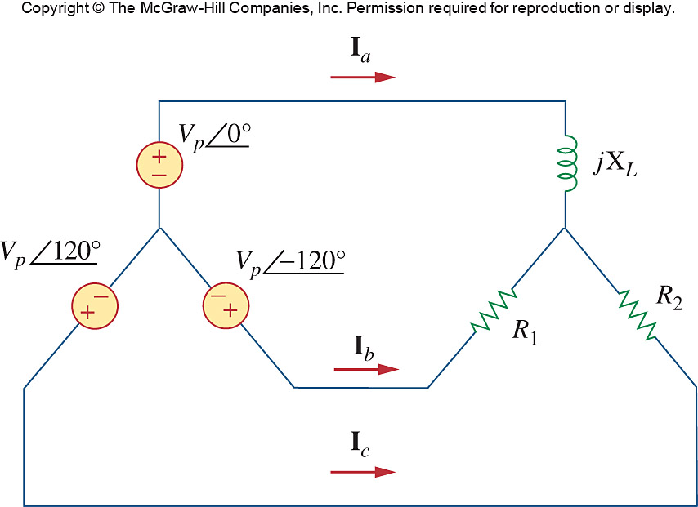

Figure 12.61
For Prob. 12.53.

